
Task 1 – designs
Nathan Share


Set Task Brief
This brief will be written out for exclusively my own reference purposes, and not to be used as any content of my own at submission time.

You work for a software development company. The company has secured a new contract to develop a digital solution for Greenfield Local Hub (GLH). GLH is a cooperative of local farmers and food producers. GLH offers:
- A single location retail outlet for locally produced food and drink
- Collective marketing for local farmers and food producers
- Product management, stock control and product traceability.

GLH (the client) would like to develop a digital solution that will:
- Provide information about the producers, their methods, and the benefits of buying locally
- Allow customers to:
  - View products with transparent pricing and availability
  - Place orders for collection or delivery
  - Manage their accounts and view order history
- Provide a dashboard to enable producers to manage stock levels, update product details and view orders.

The client has conducted market research with existing customers to identify features that could be included in the digital solution. The features suggested by the clients are:
- Order management, scheduling and tracking features
- A loyalty scheme that provides discounts and special offers
- Accessibility features to support a wide range of users

Research

The Local Harvest
The Local Harvest (Site) is a UK-wide delivery service of local goods of various types. It offers a wide range of local produce that can be ordered from places local and national, allowing you to see where your food is coming from, directly from the source.
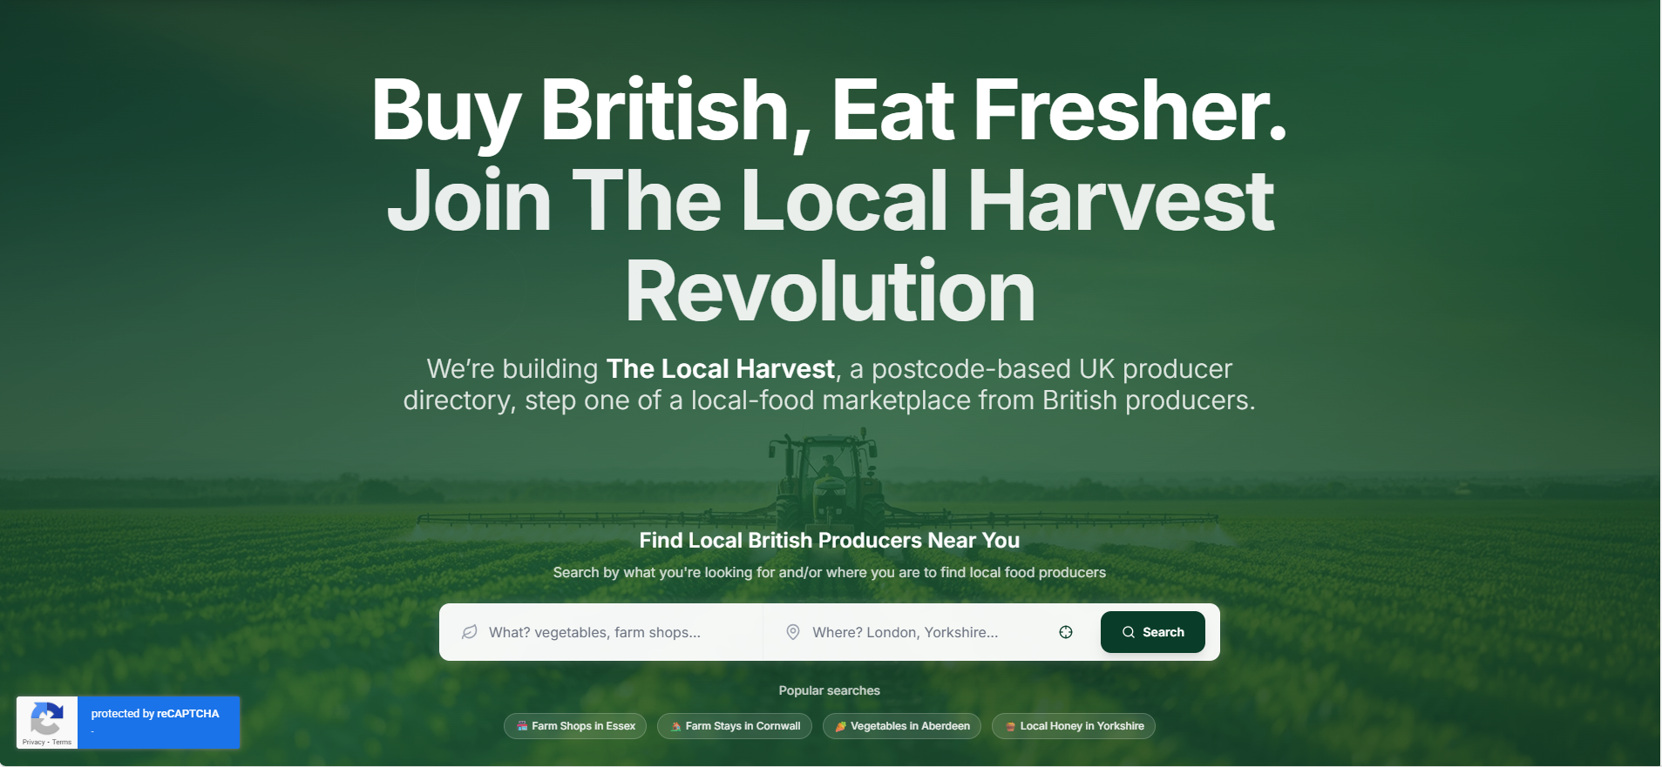
To open, the site contains 2 key things. A large catchphrase, to catch the users’ eye, and an input bar in which the user can select what they’re looking for and where. It is also worth noting that they include popular searches to help give the user a sense of direction on the site right from the get-go.
The choice of the green hue over the image in the background also immediately puts the user in mind of nature and natural products, further fitting the brand image when paired with the image of the farming process chosen.
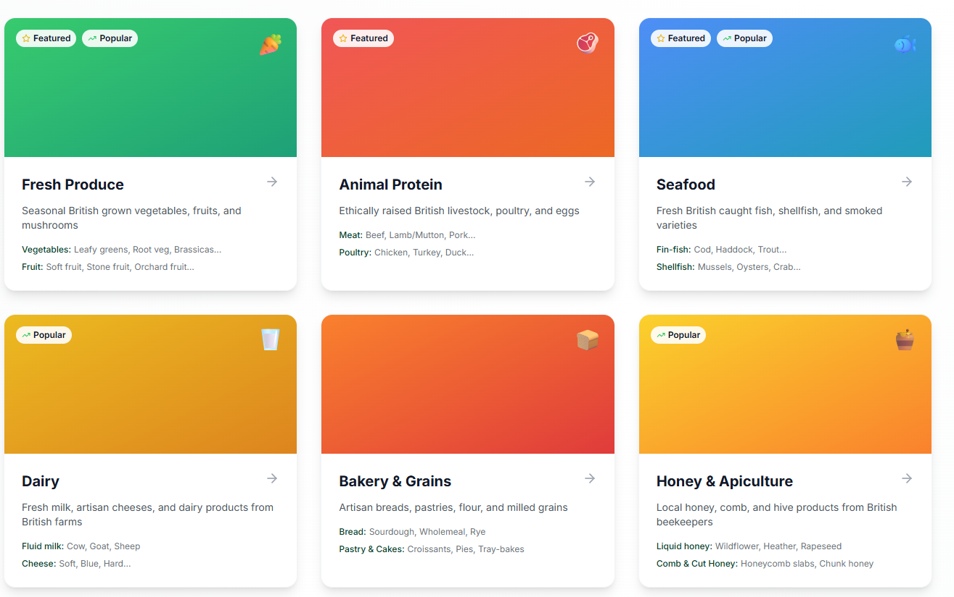
Another thing I see as worthy of note is this category searching menu. This offers a clear way for the user to choose what they would like to search for, and it offers simple and clean tags such as “Featured” or “Popular,” guiding the user to the site’s more known or popular products.
This menu also offers a small description of what kind of products to expect in each section, meaning a user can see things they may be interested in without sifting individually through each page.

Big Barn
Big barn (Site) is a similar site, offering local food produce across the UK depending on your location.
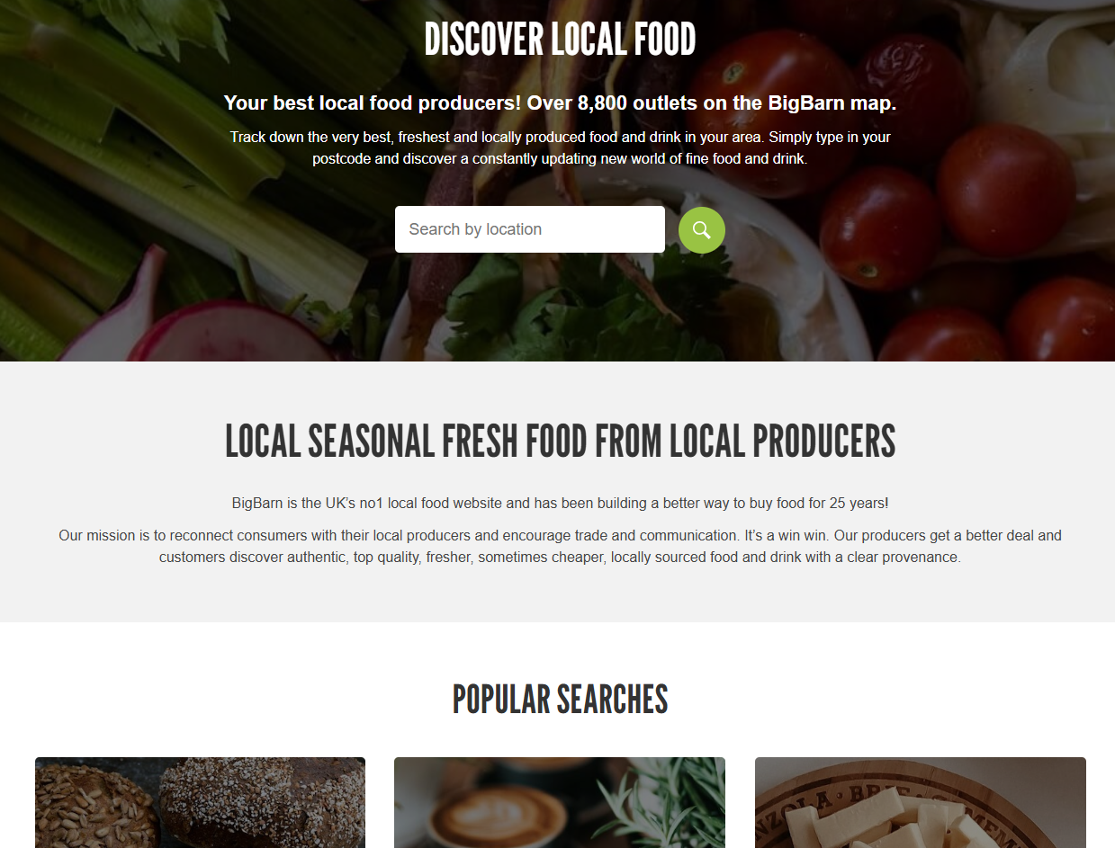
Very similarly to The Local Harvest, the Big Barn offers a hook line on the opening page in large letters – “Discover Local Food,” which immediately leaves no room for deliberation in what the site aims to do for the user. It also opens with a search bar offering the user to search for local produce by their location via a postcode. They also offer a popular search list, again offering a sense of direction to a browsing user.
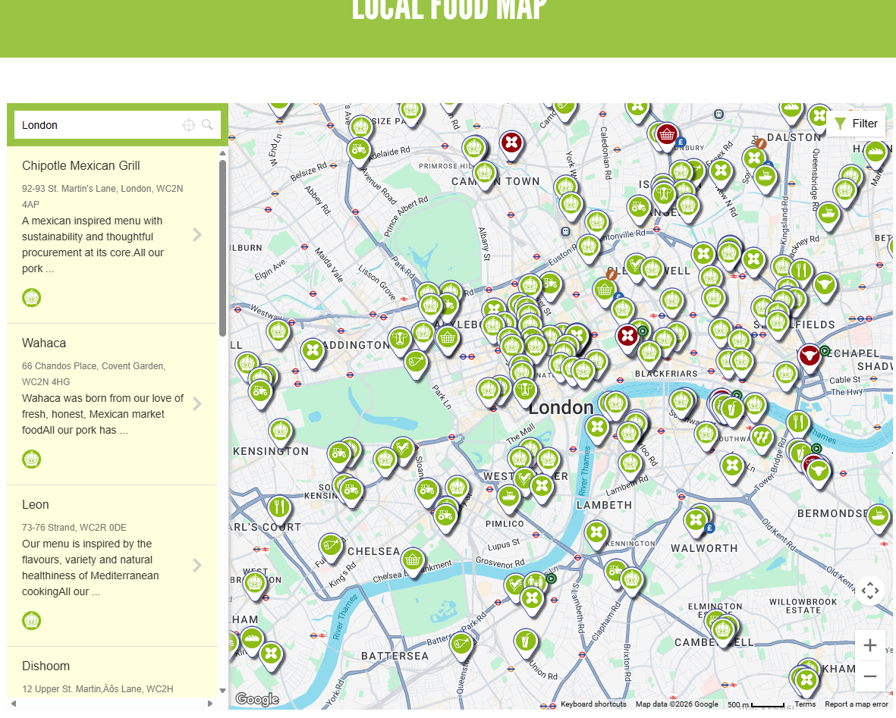Something I especially like about this site is its immediate access to a local food map, which offers itself a double-purpose. While you can order local produce from the site, it also offers itself as a way to show the user where to go should they want to buy their own food.
As you can see from the pins above, each type of shop or restaurant is visually different from one another, which offers a key to the user to see what is offered where, even at a glance. If not through a map, a way to show local food vendors would be an efficient extra feature to be added to further meet requirements.

Business Context

Provide information about the producers, their methods and the benefits of buying locally.
The client has asked me to make a solution that provides information about the producers and their methods, along with the benefits for the user of buying locally. Offering this will inform the users of the benefits of local produce and potentially the harmful side to overprocessing of food and working conditions for local farmers. Doing so may allow users to become educated on this topic and informing others. This allows word to spread and increases the amount of people who would be likely to purchase locally. This offers higher traffic to the business resulting in more revenue for both the business and its shareholders.

View products with transparent pricing and availability
Offering the capability to view products and their prices with things like taxation and delivery costs factored in removes the need for users to calculate actual costs themselves and allows the website to feel more catered to the users themselves. Offering a level of transparency to the price will help reduce the feeling that buying locally is expensive or “daunting,” allowing more users to consider buying their produce locally and through the site, again resulting in an increased revenue flow. This also solves the problem that many people believe that ordering from local sources is more expensive or difficult in some way, by breaking down that barrier and allowing the user to connect simply with local producers.

Place orders for collection or delivery
Allowing the user to order for either collection or delivery gives the user the choice on whether to collect the food themselves or (possibly at a slight increase in price) have it delivered to their door. Giving the user this level of freedom and offering a delivery system for direct-from-the-source produce is relatively untapped in the market for an affordable price, and with full customisation of the order. This would mean that the client’s solution has a unique feature to stand on, which would mean people would exclusively use GLH’s digital solution over any others’, boosting traffic and revenue massively.

Manage their accounts and view order history
Giving a user the ability to manage their account details and viewing order history is an incredibly important feature for the site as it allows for the user to find locations they liked and potentially order again or show others. This ability to cross-reference their past orders could tie-in with a button that allows them to re-order the same product again, which could offer an improved User Experience with a feature similar to that of Just Eat. This quality of life may compel a user to remain loyal to the site and therefore increase overall lasting revenue per user, including increasing the average speed at which a user places an order, both of which boosting revenue for the shareholders.

Provide a dashboard to enable producers to manage stock levels, update product details and view orders.
Producers also need to be able to use this site and offering a dashboard for the producer to change stats such as price and stock levels ties in with giving the customer a transparent price of the product and its details. This also allows producers to add information on themselves, further adding credence to the first function, in which the user must be able to view information on the producers themselves. This also solves the problem of producers finding it difficult to manage all their stock levels on a website, as it gives a simple and intuitive interface that offers a clear, 1-2 click way to update stock levels on any product they have put up for sale.

Order management, scheduling and tracking features
For a site like this, order management is imperative. The ability for the user to see what they have ordered is without question one of the most important things this site must be able to do in order to be a part of the market. This will allow users to cancel or change their orders providing that it is early enough in the process, and to see a time/location estimate on where the product currently is in its journey from grocer to customer. This solves the issue that ordering food locally or straight from the source can be difficult as delivery options are usually limited due to the smaller budget of the seller compared to that of supermarkets or large companies.

A loyalty scheme that provides discounts and special offers
Offering a loyalty scheme ties in similarly to the prior mentioned feature about seeing past orders. Offering certain bonuses (such as free delivers every few orders) for a loyal customer incentivises them to stay around and order more in the future. This increases the rate at which users will order and the likelihood of a recurring user, where other sites may lack this drive. This offers upped revenue and better overall customer incentive schemes, boosting inflow and shareholder value.

Accessibility features to support a wide range of users.
Accessibility features are nigh mandatory for compliance with Legal and Regulatory guidelines such as the WCAG and other similar forms of legalities. This is not to say these accessibility features cannot be expanded upon beyond the bare minimum, however. Offering things such as font size changing and colourblind schemes are the main things highlighted in the legal guidelines but offering a comprehensive Text-To-Speech system and light/dark mode options would further expand upon those for users who are hard of sight.

Project Aim

The aim of the project is to provide the client with a comprehensive digital solution to meet any current needs they have, as well as futureproofing their functionality for upcoming times. These goals will be achieved by producing a solution that will:
- Provide customers with information about local producers, including their methods and what kinds of products they offer
- Place an order from one or several local producers to be compiled and delivered either to the customer’s address, or for collection by the customer at a defined location.
- Manage their account details and view past orders
- Reorder past orders again, stock permitting
- Allow the user to wish list products
- Provide a dashboard for producers to manage stock levels or update product details/set up sales on their products.
- Order management, scheduling and tracking
- Offer a loyalty scheme that provides benefits to the users
- Offer accessibility settings for the users that are hard of hearing/sight.
- Offer the customer a way to view which retailers are local and their stores.
Each of these points will be expanded upon in upcoming sections.

Functional Requirements

User Profiles
Steve – Local farmer who would like to put his products up for sale to a wider audience. Older male who suffers with poor sight without his reading glasses and isn’t the best with computers.
Jeanne – Long-Term local produce buyer with 2 children who is trying to find a new way to purchase local produce after her schedule recently became full with childcare.
Alicia – New buyer of local goods who is unsure of why she should choose local farmers over larger institutions but is willing to try, and also suffers with minor Tritanopia colour-blindness.

Functional Requirements Table
Requirement | User Story | User Acceptance Criteria | Justification
Provide customers with information about local producers, including their methods and what kinds of products they offer | As Alicia, I would like to know a producer’s methods so that I better know why I should order from them.  As Jeanne, I would like to know information about a local producer so I know what kind of products they specialise in. | User can access home page  User can choose to view a grocer  Site displays details on the chosen grocer and their products  Solution must comply with WCAG (Web Content Accessibility Guidelines)  User must be able to search for a producer by name  Solution must filter to match user’s search query | Providing the customer with info about local producers helps them to know who to purchase from and why, allowing them to make an informed decision on what’s best for their money.
Place an order from one or several local producers to be compiled and delivered either to the customer’s address, or for collection by the customer at a defined location | As Jeanne, I would like to place an order from several locations that I can have delivered to my home so that I don’t have to travel to get them myself.  As Alicia, I would like to place an order for collection so that I can drive to a local designated drop-off area so that I can drive to get my products without having to pay delivery cost. | User must be able to log in to their account  User must be able to navigate to viewing products  User must be able to select a product and quantity  User must be able to add product to basket  User must be able to select drop-off or delivery  Solution must factor in delivery costs if that is user’s selection  User must be able to choose a local designated drop-off spot if that is their choice  User must be able to input a postcode for delivery if that is their choice.  Solution must validate inputs of postcodes  Order must be linked to customer and go through into order menu.  Solution must comply with WCAG (Web Content Accessibility Guidelines) | Allowing the user to place an order for either pickup or delivery offers options to the customer, allowing them to get their products the way they want to, with regards to their availability and wants or needs.
Manage their account details and view past orders | As Steve, I would like to manage my account details so that I can change my password to keep my account safe from hackers.  As Alicia, I would like to change my details so that I can change my address and postcode, should I move house.  As Jeanne, I would like to view my past orders so I can quickly reorder the same products as before without having to hunt down the producers’ stores again. | User must be able to log in to their account after registry  User must be able to navigate to their account menu  User must be able to choose which details to edit.  User must be able to change the selected detail  Solution must reflect updated detail in the database  User account must reflect updated details.  User must be able to navigate to “past orders” tab  Solution must keep track of a user’s past orders.  Solution must comply with WCAG (Web Content Accessibility Guidelines) | Offering the ability to manage account details is needed in case the user feels that they need to edit their password or linked e-mail address should it need to change for any reason. This also complies with legalities to do with a user’s right to change and edit their data at will.
Reorder past orders again, stock permitting | As Jeanne, I would like to reorder past orders so that I can order quickly and not have to divert my attention from my busy schedule for too long. | User must be able to log in to their account after registry  User must be able to navigate to their account page  User must be able to navigate to “past orders” tab  User must be able to click “Order Again” button.  Cart must automatically refill with the same products and take user to order screen.  User must be able to input details and order for pickup or delivery. | Offering the user the capability to reorder allows for them to efficiently order what they like, should they not feel the need to change it.
Allow the user to wish list products | As Alicia, I would like to wish-list products so that I can keep an eye on new products I would like to try when they go on sale or lower in price. | User must be able to log in to their account  User must be able to view products  User must be able to wish-list a chosen product  User must be able to navigate to wish-list button  Solution must reflect that user’s wish-list of products. | Allowing the user to wish-list products allows them to keep an eye on the things they like, offering a more efficient user experience than manually searching up the same products to find out if their details have changed.
Provide a dashboard for producers to manage stock levels or update product details/set up sales on their products. | As Steve, I would like to view a dashboard for my products so that I can change the price or stock level of my products within one or two clicks/drop-down menus | Staff user must be able to log in  Staff must have a different layout of site  Staff user must be able to navigate to “My Store” page  Staff must be able to select a product from their store  Staff must be able to edit product info  Staff must be able to increase/decrease price or stock  Solution must comply with WCAG (Web Content Accessibility Guidelines) | Offering a dashboard for staff users gives them the ability to update product details in a clean way, improving UX for Staff and resulting to a minimised chance of error with pricing or order details.
Order management, scheduling and tracking | As Alicia, I would like to track the location of my orders and get an estimated time of arrival so that I know when to set out and pick them up from the drop-off spot.  As Jeanne, I would like to change my order details in case I mistakenly order the wrong thing and would like to change it before shipping.  As Steve, I would like to track orders I have sent out so that I can see where my products are and that they have made it to the customer well. | User must be able to log into their account  User must be able to navigate to “Orders” tab  Solution must reflect user’s current orders  Solution must display status of order according to staff  Staff must be able to update order status  User must be able to edit details if order has not yet been packaged  User must be able to cancel order if order has not yet been packaged  Solution must comply with WCAG (Web Content Accessibility Guidelines) | Allowing for the customer and staff to edit the status or details of an order at certain points allows for all parties to stay informed on what is expected and what can or can’t be changed. This offers extra communication between customer and grocer, allowing a better User experience for both.
Offer a loyalty scheme that provides benefits to the users | As Jeanne, I would like a loyalty points scheme so that I can gain benefits for staying loyal to the site for extended periods of time. | User must be able to log into their account  User must be able to navigate to rewards page  User must be able to see their rewards points  User must be able to redeem rewards points for certain bonuses (vouchers, free delivery, etc.)  Users must gain rewards points every time an order is successfully shipped to them  Rewards points must be gained at a rate of 1 per 10p of total order cost  Solution must comply with WCAG (Web Content Accessibility Guidelines) | Offering a loyalty scheme incentivises users to stay and continue to choose this solution over potential competitors, whilst upping the likelihood that a customer will order again.
Offer accessibility settings for the users that are hard of hearing/sight. | As Steve, I would like accessibility settings so that I can use the site even without my glasses to help me see.  As Alicia, I would like accessibility settings to offer a colourblind setting for my Tritanopia | User must be able to navigate to settings page  User must be able to change accessibility settings  If user is logged in, settings must save to the user’s account.  User must be able to toggle between light/dark mode or system default.  Solution must comply with WCAG (Web Content Accessibility Guidelines) | Offering accessibility widens the potential market of customers and grocers who would be able to access the site and its contents without difficulty. This Improves user experience and allows for a greater general access capability for all kinds of user. This also complies with legal standards globally.
Offer the customer a way to view which retailers are local and their stores. | As Jeanne, I would like to know which retailers are closest to me so that I can order from places that will make it to me faster and fresher.  As Alicia, I would like to know where is local to me so that I know where I can drive to, in order to pick up my orders. | User must be able to input a chosen town/city from a dropdown menu  Solution must search database for retailers local to chosen city/town  Solution must display local retailers  Solution must comply with WCAG (Web Content Accessibility Guidelines) | Allowing the customer to view where local retailers are keeps the industry standard practice of other businesses in the market and allows the user to see that there is local producers near to them who could offer goods close enough for fast and fresh delivery.

Non-Functional Requirements

Non-functional Requirement Table
Performance
Non-Functional Requirement | Justification | KPI
Pages must load at a consistently high speed | If pages load slowly, users may be compelled to find a faster alternative. | Site must be able to load any page within a maximum of 3 seconds after the user has clicked on a button or link.
Images must all be high quality | Low quality images can be hard to visually understand which can impair user experience | All images must be at least 1920x1080, the standard FHD resolution.
All media, including images, videos and embeds, must load quickly | If media loads slowly, page formatting may encounter errors and overall site performance is lowered. | All media must load within a further 5 seconds of the page loading, for a total of 8 seconds maximum load time.
Any search or filtering options must update quickly and consistently, whilst remaining correct. | If search filters take an exceedingly long time, users may grow annoyed and less compelled to use the site due to bad performance. | All search or filtering options must load between 0.1s (Buffer time) and 1.5s
All pages related to ordering and all input fields in the ordering process must be high speed in both responsiveness and validation. | Ordering is the last step of the process and so users will be more observant of bad performance as they are now moving through the solution with an intent to order. | All pages of the ordering process must load within 2 seconds and input fields must contain less than 0.05s input delay on any field.
Security
Non-Functional Requirement | Justification | KPI
All input fields must be validated where applicable | If input fields aren’t validated, it is easier for SQL injections to damage the solution. | 100% of applicable input fields should be entirely validated to limit what the user can type and submit in them.
Pages must apply to user role hierarchy | If pages do not apply to role hierarchy, then users will be able to get to pages that they shouldn’t normally be able to. | All pages must apply to a role hierarchy, involving a logged-in user, a logged-out guest, a staff role, and an admin role.
Account E-Mails must all be confirmed as valid before the user can log in to that account. | If E-mails are allowed in whilst unvalidated, this massively increases the likelihood of DDoS or botting attacks. | 100% of account E-mails must be validated through an email sender (or placeholder for the prototype)
Passwords must be encrypted and stored safely | Encrypting passwords with a password hash will stop anyone with access to the backend database from seeing users’ sensitive details. | All passwords must be encrypted in the backend by a hashing system.
Solution must include a role hierarchy structure, including an admin user with full access | If the solution did not contain a role hierarchy, producers would not be able to differentiate themselves from the consumer users. | Solution must allow different access rights to users depending on if they’re logged in or not, and what kind of account they’re logged in to.
Scalability
Non-Functional Requirement | Justification | KPI
System must be fully scalable, accounting for gradual increases in traffic over time and larger spikes in periods where many users log in at once. | If the site suffers under high-traffic periods, whether now or in the future, it could crash which could harm reputation and cause potential damage with data or orders. | The solution must perform well at all times, including on known user spike points for purchasing goods.
Code should be scalable and commented to allow for easy integration of new features in any given part of the site. | Code being readable allows for future developers working on the solution to improve what the client already has in place. The better the code is commented, the less room there is for error in future. | Code must be consistently commented throughout to a high quality, indicating where to add more things should it become necessary.
New services or features must be integrated smoothly, with little-no initial errors | New features will eventually be requested when a website is scaled up, and a good website should be able to handle these new features without being sent down for maintenance for a long period, as this can harm reputation with the customers and lower effective time for revenue gathering. | Any new services implemented by the client or freelancers hired by the client must not impact performance in the short or long term, and must require a maximum of 36 hours of downtime to implement fully.
Capacity
Non-Functional Requirement | Justification | KPI
Individual pages must be able to handle high traffic | If an important page that the user is likely to go to first, such as the homepage or the register page, crashes, this can push the whole website into downtime and stop users from being able to navigate through. | Each individual page must be able to handle a maximum of 10,000 active user browsing it at any given time without reporting performance issues.
Any and all filtering or search fields must be able to handle multiple users utilising them in different instances. | As the number of partnered grocers increases over time, users will need to sift through more and more data to find local places that work for them. If the search bar moves slowly, this can damage user experience and reputation. | Any filtering or search methods must be able to handle up to 750 users before performance is impacted.
General system must be able to cope with high traffic spikes. | A grocery site such as this may be someone’s go-to for highly important shopping, and if it goes down for an extensive period due to a high-traffic spike, then this could lead to serious reputation losses or impact on the average user. | The entire solution must be able to handle a minimum of 100,000 active users without reporting a performance drop.
Data storage systems must be to a minimum of 100TB, with room for upscaling should it become necessary | A system such as this has multiple nested databases that it will have to handle and work internally. These will be ever-growing and so data storage must also be capable of growth to match that. | Data storage systems for the solution must be able to hold a minimum of 100 Terabytes of data, with room for this to increase.
Accounts with a notable lack of activity over an extended period must be marked as “inactive,” meaning that should the user choose to log back in, they will need to fill in some details again. | Minimising irrelevant or old data is important for a database of ever-growing users with a constant need for storage space, and marking accounts as inactive, only storing the bare minimum information on them can help save space and filter out old data. | Accounts with no activity over a 6 month period must be marked as inactive to minimise unnecessary data in the database.
Reliability
Non-Functional Requirement | Justification | KPI
The solution must be able to handle downtime and return to full performance quickly | If the solution cannot handle recovery after scheduled downtime quickly, it will suffer extensive periods where performance is lowered and user experience is minimal. This also applies to loading media and images throughout the site. | System uptime must maintain an average of 99% over any given 30-day period of time.
The solution must have backups of orders in the event of a crash or technical fault. | If the solution is to suffer any kind of fault or error, whether it malicious, natural, or technical, order information cannot afford to be lost. This could result in the loss of lots of food products due to their order information being lost to the system. Backups would help to eliminate this issue from being as much of a problem. | The system should backup order data to a backup server once every 6-12 hours, in order to keep information updated.
The solution must include a user capacity for each page and the whole website that leads to a queue time to avoid crashes or malfunctioning/bad performance. | Queue pages are an industry-standard way of limiting user counts in most kinds of technical scenarios, from websites to video games. This would offer a reduced likelihood of needing downtime or of the solution crashing due to an immense concurrent user count. | After a total of 85,000 users are concurrently on the entire site, or 8,500 on a single page, the solution should redirect users to a queue before allowing them to access the overcrowded area.
Solution must contain backups of user data in an offsite server location or cloud in the event of a crash or fault. | Keeping a physical backup server of user data will help to minimise the risk of losing this data in a crash or major error resulting in damage to the main servers. This is especially important when attempting to create a loyalty system, as users may be upset at these being lost in the case of an error. | Solution must have an offsite backup containing all user data that is refreshed every 24 hours to keep user accounts safely stored.
Usability
Non-Functional Requirement | Justification | KPI
Users must be able to follow all links to the correct locations | If the user clicks a link that says “Homepage” and it takes them to the products page, this may cause general confusion and make site navigation unnecessarily difficult. | Links must redirect to the correct logical page, whether internal or external, 100% of the time.
Navigation menu must be functional and remain as such on every page of the site. | The navigation menu must be consistent on every page as it is the primary, industry-standard way for the user to navigate through most sites today, and it is what most people are used to doing. | Navigation buttons must remain consistent in the header of every page and must redirect correctly 100% of the time.
Solution must display errors in a colloquial and understandable way to the user. | If the solution displays errors as an exceedingly long string of letters and numbers that most people cannot understand, not only will this be difficult to report to a support team should that be necessary, but it may also intimidate the user and make them dubious about using the site again. | Solution must add a tip to go with errors or invalid inputs. (e.g.: Error 404: Page not found)
Header and Footer bar must remain consistent on all pages, with only the central “body” of the page changing. | A header and footer bar are a keystone of most websites, as probably the most important industry standard option there is. This means that should a page be missing them where all other pages are not, the user may be confused or stuck, lowering user experience. | Header and footer bar must remain visually present and consistent on 100% of pages.
Accessibility
Non-Functional Requirement | Justification | KPI
Alt text must be included on all images or media | The solution must contain an alt text on images both for users who find it hard to see, and in case an image does not load. | 100% of images present on the site must contain alt text
Solution must include a colourblind mode, including high-contrast visual mode. | The solution must contain a colourblind mode for each type of colour-blindness, and a high-contrast mode for those who are hard of sight, in order to comply with the WCAG. | Solution must contain 3 kinds of Colourblind mode, for protanopia, deuteranopia, and tritanopia sufferers. It must also include 1 High-contrast mode for the visually impaired.
Solution must consistently comply with Web Content Accessibility Guidelines | The solution must comply with the WCAG in order to remain up legally without facing fines or reprimands legally. It also improves User Experience. | 100% of pages must comply wholly with the WCAG in its entirety.
Solution must offer light, dark, and system default themes. | The solution must offer a light and dark mode to match most industry-standard competitors, who offer this for people who prefer the less-bright visual styles. | Solution must offer a light and dark mode depending on the user preference, and an option to sync with the system default settings.
Solution must offer Text-To-Speech translation on all pages | The solution must offer text-to-speech in order to comply with WCAG and to assist users who suffer with poor eyesight yet still want to use the site. | 100% of pages must be compatible with a text-to-speech setting for the visually impaired.
Solution must offer font resizing options. | The solution must offer font resizing options to comply with the WCAG and to assist users who suffer with poor eyesight. | All fonts on each page of the solution must be able to be resized within the accessibility settings.

Hierarchy Diagram
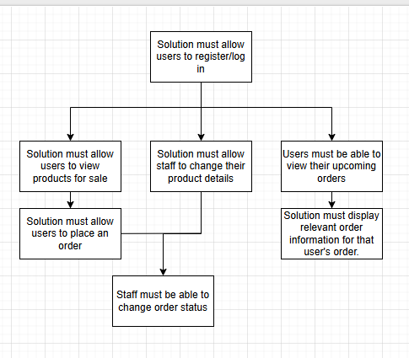

UI Considerations

For my UI design, I often saw in the research websites that colours that remind the user of a natural scene had been used, possibly to tie in with the organic theme that the websites offered. This includes greens, beiges and yellows.
For my primary feature colour, I would like to highlight a dark green, similar to This (#0A760D). This would be used primarily for buttons, and the background colour of the header bar. For the majority, the background body of my website will be white, but some certain areas I may choose to highlight with a parchment-like beige, such as This (#F1E9D2) to further put the user in mind of an organic or natural colour theme. This would likely be used to separate out some areas over others and create a visual divide that isn’t massively jarring against the standard white background.

For my font styling, I would prefer to go for something like Garamond or Times New Roman as these web-safe, serif fonts create more of a hand-typed, professional look, more akin to classic newspapers or typewriter writing. I would likely use these for headings, and use a standard sans-serif web-safe font such as Tahoma for my main text bodies, as serif fonts can be overused to look visually cluttered or unappealing, especially when in a smaller font size. This, when paired with the greens and beiges will emphasise the organic visuals, creating a clear and consistent theme that further distinguishes the website from others on the market.

Security Considerations

Risks and Mitigations
Code | Risk | Mitigation | Likelihood | Impact | Threat
R1 | Server Shutdown | To mitigate a potential server shutdown, servers are regularly maintained both digitally and physically, ensuring their consistent running. Servers can also be supplied with backup power, so that in the event of an outage, servers can stay running for a set period of time without issue. Finally, I have also included a need for offsite backups in case of a server shutdown event. | Low | High | Medium
R2 | DDoS Attack | To stop the likelihood of a DDoS attack, I will ensure that all emails entered into the database are verified manually to negate the chance of bot accounts being registered. Queue times will also be set in place in case of a high traffic spike, allowing only a set amount of users on any given page to mitigate potential crashes or damage. | Very Low | Severe | Low
R3 | Brute Force Attack | To mitigate a brute force attack, I have ensured that old accounts will be deactivated, removing the number of viable passwords, and that several checks are undergone for new passwords, such as length and validation checks. | Medium | High | High
R4 | SQL Injection | SQL Injection risk is mitigated automatically by the ASP.NET MVC architecture, which takes potential malicious SQL code in queries and treats it at normal text, rather than exactable code. | Low | Severe | Med. Low
R5 | XXS attack | To mitigate an XXS attack, I will ensure than any user inputted fields are encoded upon being sent to the database and decoded as text when they need to be called. This stops them from being read as malicious code lines. | Medium | High | Med. High
R6 | Severe weather | In order to mitigate the damage done by severe weather, I have suggested a cloud or offsite backup of user and order data, so that should a severe weather event (e.g.: Hurricane, Earthquake, Etc.) damage the servers, the data could still be up and running effectively. | Very Low | Severe | Low
R7 | Internal Threats | Internal threats, such as a disgruntled employee in the company, is a difficult threat to mitigate. The most mitigation possible is to ensure that passwords in the database are hashed and that the average employee does not have access to another users’ full account details at any given time. | Medium | Medium | Medium
R8 | Order Failures | A failed order is a common thing in online shopping or grocery deliveries. It is not something that can easily be mitigated but the damage can be helped by recouping the costs through a refund to the customer, in order to minimise any bad press. If this becomes too common however, it could become a more severe issue. | High | Very Low | Med. Low
R9 | Unreliable Outsourcing or logistics | The nature of the company solution is to outsource local businesses and offer them a wider market, and this may not always be a reliable service. Some delivery drivers may steal orders for themselves, and some grocers may misremember orders or forget things. This can only be mitigated after the fact by offering the wronged customer either a refund or a bonus to their loyalty points, depending on the severity of the case. | Low | High | Medium
R10 | Malicious Producers (Scams) | Malicious sellers are a huge issue for online retail, and the best way to mitigate this is to confirm emails upon registering an account, and to make sure that someone who is looking to become a seller has to verify themselves in some way beforehand. | Medium | Medium | Medium
R11 | Pricing errors | Pricing errors are a common thing, in which things are not written correctly and prices may accidentally be marked down or up by far more than was originally intended. The best mitigation for this would be to offer a confirmation screen before the seller confirms their updated details, which may only be confirmed via an input that unlocks after a few seconds. This gives the seller chance to read their changes and make sure they’re correct. This would also be covered in the Ts and Cs as not the company’s liability. | High | Very Low | Med. Low

Legal and Regulatory Guideline Considerations

Digital Legal Compliances by the solution
To create a site of this nature, several guidelines will need to be followed. Firstly, the most notable guideline to be followed (and possibly the simplest) is the WCAG, or Web Content Accessibility Guidelines. There are several features deemed mandatory for accessibility functions on any website to allow users with potential disabilities to have a better, more inclusive user experience. A few of these features include text resizers, a TTS (Text-To-Speech) function, and colourblind/high contrast modes. On top of these, I will also include a Dark/Light mode switch for added compliance with accessibility needs, which will have the option to synchronise with the system default settings of the user. This will improve the UX for a wider market and make the solution more accessible than some others in a similar field, while complying entirely with the WCAG, so long as these features are implemented and work on each page in the solution.
The second legal act to be followed will be the GDPR (General Data Protection Regulations) and DPA (Data Protection Act) guidelines, as user data is being stored and collected. These enforce the security of user data on the site and informing the user of the data that may be collected by the client throughout their time using the website. This is a little more complex to comply with, but it is still entirely doable. I will be including a password encryption service, and hashed passwords in the backend database, alongside a censored password input box to lower the likelihood of shoulder surfing or database breaches. I will offer a pop-up informing the user that the website may use cookies, and it will contain a button that is a positive action (e.g.: Button click, box tick, etc.) confirming their consent to collect cookies for a better user experience. This ensures that user consent is met, improving compliance with GDPR and DPA regulations in a non-intrusive and effective way.
In further compliance, I will also offer a terms & conditions window that the user can click to confirm or deny consent to – again, through a positive action, as this is mandated by the GDPR and DPA guidelines – that offers another link that the user can click to view and read the Terms and Conditions, along with the Privacy Policy and data that will be collected. This allows the company to mitigate most legal claims against them as it adds a layer of user consent to what the company does. It also allows the client to legally have grounds against scamming, spamming or hacking or any malicious attacks, reducing the likelihood of such an attack occurring. This window will further ensure compliance with GDPR and DPA as it allows the user a way to see what data is being collected and their rights regarding it.

Non-Digital Legal compliances by the solution

Most non-digital compliances by the site are aimed towards the grocers who intend to use the site, as they often have to comply with many legalities in regards to the quality of their food and the overall safety standards.
Through a series of tick boxes upon either signing up as a valid seller or registering a new product, the seller must confirm that they are complying with Food safety standards, Licensing and permits regarding food handling and growing, Consumer Protection, and their right to fair pricing and refunds, and Insurance of their product. These will all be covered in the Ts and Cs with legal action should this be a false claim by the seller.
Finally, the client will have to add into the Terms and Conditions or other policy that they are responsible for the insurance of the outsourced delivery workers, should something bad happen to them or their property whilst on the grounds of an affiliated location. This includes sellers’ land, but not on the road or during the delivering to the customer
-Food safety Standards
-Licensing and Permits
-Consumer Protection
-Insurance Requirements (Delivery Outsourcing)

